“Little Cracks of Their Own Mountain Ranges”: The Bark Petition, Church Panels, the Gove Land Rights Case

The Formation of Aboriginal Australia’s First Title Deed

Peter Botsman
July 7 2013
“…there are moments of illumination when the mind expands under the force of new horizons … men such as Djawa and Narritjin could expose little cracks of their own mountain ranges … that made areas of understanding possible.” Edgar Wells, Letter to Ed Ruhe, 1983.

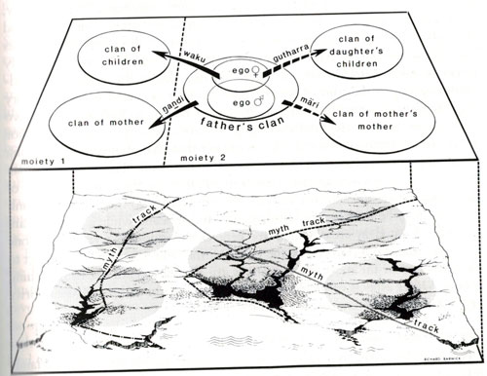

This marvellous diagram of the mari – gutthara clans and estates (from Nancy M. Williams book The Yolngu and their Land: A System of Land Tenure and the Fight for its Recognition, Stanford University Press, 1986) was conceived 16 years after the Gove Land Rights case. It took an intellectual of great standing to show how Justice Blackburn had so badly misunderstood the nature of Yolngu land tenure, stewardship and ownership. 50 years later we are still only beginners in understanding one of the most sophisticated and wise land management systems ever conceived by man. Let us hope our children and grandchildren learn much more…

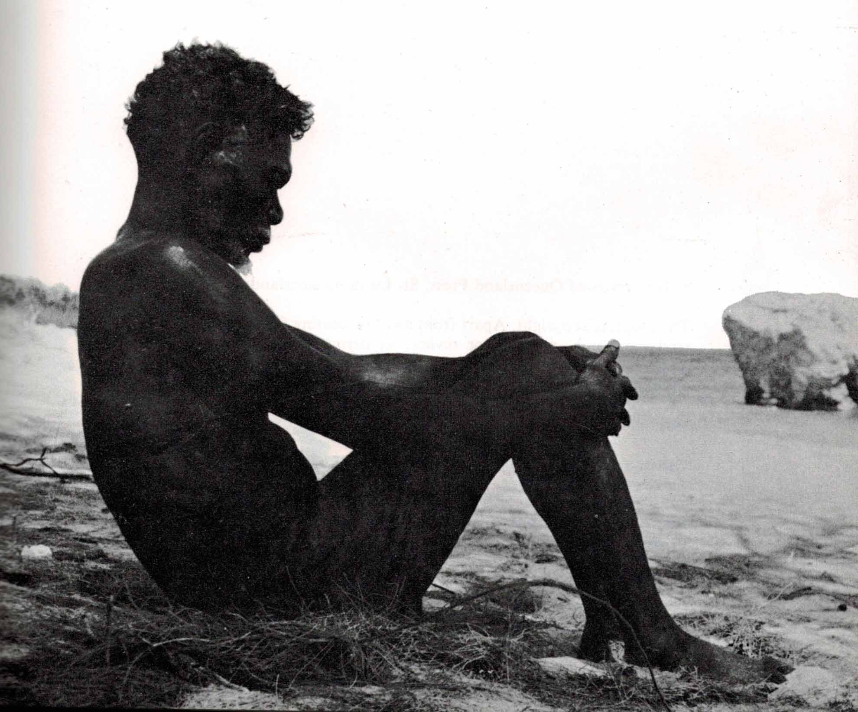
Mawalan, Turtle Rock, from Anne Wells This Their Dreaming Legends of the Panels of Aboriginal Art in the Yirrkala Church, University of Queensland Press, 1971

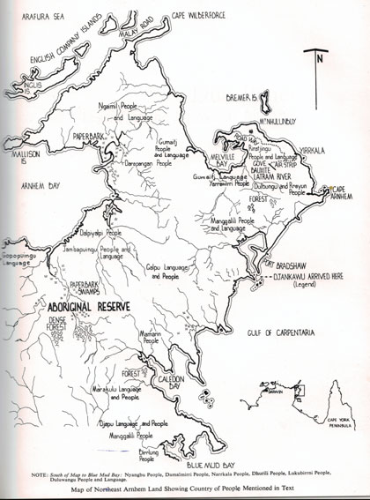
Most Australian recognise this map but it provided only a one dimensional and rudimentary “Western” representation of the Yolngu land and estates referenced in the Yirrkala Church Panels, from Anne Wells, This Their Dreaming Legends of the Panels of Aboriginal Art in the Yirrkala Church, University of Queensland Press, 1971

In traditional Aboriginal Australia there was no legal title, no piece of paper kept in a safe spot to demonstrate legal ownership of a piece of land, as in Western law. The story of the Yirrkala bark petition is the story of how Aboriginal Australia explained the origins of their land ownership, their responsibilities of land stewardship and of the family management of land (mari (grandmother), gutharra (grand-daughter), yothu yindi relations) over many generations.
Fifty years later we can now partially see the marvellous system of stewardship, connection and ownership of lands that the Yolngu elders tried to explain to Australian politicians, courts and to the Australian people. In painting the church panels, and in framing the bark petition they were indeed creating their own, and Australia’s first native title deed, for all to see. The remarkable aspect of what they did is that we will as a nation and as a group of intellectually enlightened people be studying the bark petition for a long way into the future. From this all Aboriginal lands and peoples could be better understood. From this we could appreciate the qualities of our land and our people in a new, sophisticated and engaging way.
Up until now, the bark petition has been seen as a kind of civil rights document in the thinking of our politicians. But fifty years on we see that it is the remarkable and wise system of land tenure, that it has a connection with the way land, flora and fauna is managed, that it is effectively a way of guaranteeing wise tenure and use of lands and that it has a deeply spiritual meaning which we are only just beginning to understand.
The rights and entitlement of land was something each Aboriginal person was born with. The bundle of rights that are tied to property title in Western law, for example, water and riparian, mineral, easement, tenancy, timber, farming, grazing, hunting and air rights came to each person, primarily through their father’s hereditary rights and secondarily, through their maternal hereditary rights. The landed estates of Aboriginal clans were territories that came to clan members from the beginning of time and were subject to ceremonial and customary kinship relationships. Nothing could be bought or sold. But rights could be traded and loaned to other groups. Wars in which whole clans were wiped out might involve a resetting of territorial boundaries but nothing altered the underlying primordial order of property rights.
It is remarkable, arrogant and ignorant for Australians not to have recognised the oldest system of land ownership.
In North East Arnhem land the creation of an Aboriginal protectorate in 1931 meant that the age-old system of Aboriginal property rights, and the ceremonial and customary law of the Yolngu people, carried on relatively undisturbed until the late 1950s. During this time missions did create significant changes in that Aboriginal people were encouraged, for the first time, to settle in particular areas supported by Western horticulture, transport infrastructure and housing. Modern technology and artifacts including steel, refrigeration, fabrics, timber manufactures, not to mention, sugar and alcohol, all had profound effects on Yolngu society. There was also a mediation of traditional value systems by Christianity. In Arnhem land, there was a paternal encouragement of Yolngu culture by missionaries, as Ann Wells wrote: “..it was no good for humanity to be ashamed of those of their own kind who had gone before them along the roads of this world; men should not come with either arrogance or apology into the brotherhood of man, but with head erect and heart at peace as into the company of friends and relations”. Ann’s husband Reverend E.A. Wells believed that he was very much a protector of Yolngu people, as much as a Christian missionary. From the Yolngu perspective as Mawalan Marika stated clearly: “I’m not going to be Christian but I come as Christian to the missionary to learn about the Bible, because your story fit into our story, but my story is Law and is Christian before you arrive”.
The granting of mining leases from 1958 disrupted the relatively harmonious relations that existed between what Wandjuk Marika came to view as “manymak” (good) “balanda” (European people) in the form of missionaries and yetj (malevolent) balanda (Europeans).
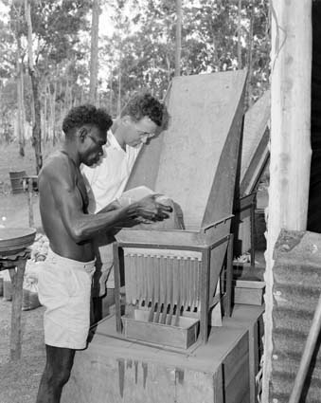
Gove Bauxite Testing, 1958
The radical excision of lands in the Wessell Islands heralded a different era in which the Yolngu leaders became politicised in order to protect their age old property rights. The Yolngu response to balanda required and the Gove Peninsula for the mining of bauxite prompted the creation of the most unique and elaborate expression of the timeless relationship of the Yolngu people to their lands. The painting of the Yirrkala church panels was in direct response to the Commonwealth and Territory governments grab of significant parts of the Aboriginal reserve without consultation with the traditional owners. Yolngu clan leaders created an Aboriginal version of Michelangelo’s Sistine Chapel depiction of the tribulations of Christ to explain the nature, strength and wisdom of their system of land ownership and tenure.
Edgar Wells the Methodist missionary at Yirrkala, and his wife Anne, deserve some recognition in what Howard Morphy has aptly called a process of “mutual conversion”. The great Yolngu leader Narritjin Maymuru convinced Wells that their needed to be an explanation of the Yolngu laws, sacred beliefs and land system. As Wells noted to this friend the panels allowed the two moitey clan groups to “expose little cracks of their own mountain ranges”. The Church panels are one of the greatest works of art that has ever been produced in Australia. Researchers and scholars will be studying them for the next hundred years and will still find new dimensions, ideas and inner secrets that are associated with them.
The paintings were a response to the mineral explorations and to concerns over the possible granting of a mining lease over the bauxite reserves on
the Gove Peninsula. They led directly to the Yirrkala Bark Petition that was sent to the Commonwealth parliament in the following year. Kim Beazley senior saw the panels in the Church, and suggested that this would be an appropriate way to petition parliament using the symbolic medium of Yolŋu religion and law. The Gove Land Rights case can be seen as a logical outcome of the dialogue that occurred.

Timeline
1931 The greater part of Arnhem Land 31,200 square miles is proclaimed an Aboriginal Reserve. The total area of reserves for Aboriginal people in the Northern Territory is 60,000 square miles. In addition pastoral leases under the Crown Lands ordinance should contain a reservation giving to all Aborigines and their descendants “Full and free right of ingress, egress and regress into, upon and over the leased land, and every part thereof, and in and to the springs, and natural surface waters thereon such wurlies and other dwellings as those aboriginal inhabitants have before the commencement of the lease been accustomed to make and erect and to take and use for food, birds and animals ferae naturae in such manner qas they would have been entitled to do if the lease had note been made”. (Cited Barrier Miner, Sept 1931, p. 1)
1950 Capt Fred Wells and Fred Waulkes discover bauxite at the Wessel Islands, Arnhem Land
1952 Australian Aluminium Company granted permission to prospect for bauxite across Arnhem Land Aboriginal Reserve
1955 Wessel Islands Mining Company fails and the stock and buildings of the failed venture are distributed to the five Methodist Overseas Missions in Northern Australia
18 December 1958, Commonwealth Aluminium Corporation granted a special mineral lease of 22 square miles over the bauxite deposits of the Gove Peninsula. Corporation to submit plan for development of the area within five years.
18 April, 1961 Commonwealth House of Representatives appoints a select committee to inquire into the voting rights of Aborigines under the Electoral Act, 1918 to 1953 which reports on 17 October 1961
18 February 1963 Prime Minister Robert Menzies announces 50 million mining project in Arnhem Land together with the granting of mining leases following an excision of Yirrkala Aboriginal Reserve
11 April 1963 Cyclone ravages Arnhem Land
2 May 1963 Rev. Edgar Wells chairs meeting with mining representatives and Yolngu leaders
9 May 1963 Rev Wells calls a public meeting and reads proclamation by the Governor General of mining lease and and areas adjacent from the Aboriginal Reserve.
23 June 1963 Rev. C. F. Gribble opens the new church at Yirrkala and dedicates the church panels included in the Church.
16 July 1963 Kim Beazley Snr and Gordon Bryant arrive at Yirrkala and stay for a week. The “Bark Petition” is drawn up.
24 July 1963 The Bark Petition is sent to Canberra
12 September 1963 Mr Beazley moved, ‘That a select committee be appointed t o inquire i n t o the grievances of certain aboriginal people o f Yirrkala . . .’ Debate ensued and the question was put and passed
30/31 October 1963 Findings of the Select Committee included:
“Paragraph 43
Your Committee finds that no discussion took place between Administration represen- tatives and the Yirrkala people before excision. The discussion was between the Administration and the Methodist Mission authorities.
Paragraph 44
Your committee is of the opinion that it was not an obligation on the Yirrkala Mission authorities to inform the Yirrkala people of Government policy, even if they had been completely certain what i t was. Confusion seems to have arisen on this point. The Administration apparently thought that the decision had been given to the people.
Paragraph 47
Your Committee was impressed by the quality of the aboriginal evidence given in their own tongue . . .
Paragraph 59
Evidence showed that no conference had been held with the Aborigines to discover the precise location of sacred places, although provision was made in respect of sacred places in the collateral letter to the Special Mineral Leases.
Paragraph 61
Paragraph 65
. . . there are many sacred places within the whole of the excised area. Your Committee believes t h a t the people of Yirrkala still need the protection that the pro-clamation of a reserve gives them from the intrusion of Europeans who have no good reason for going among them.
Paragraph 68
Your Committee believes it is necessary to develop simultaneously homes for European Australians and Aboriginal Australians.
Paragraph 69
. . . your Committee considers that some compensation is due in the form of land grants and suggests action under the Ordinance for leases for agricultural purposes . . .
Report from the House of Representatives Select Commi t t e e on Grievances of Yirrkala A b o i g i n e s , op. cit., Pt I ,
Report and Minutes o f Proceedings.
94 . . . your Committee believes that a direct monetary compensation should be paid for any loss of traditional occupancy, even though these rights are not legally expressed under the laws of the Northern Territory.
Paragraph 74 . . . Your Committee considers that at least the first 150,OOO pounds in royalties should go to meet the capital needs of the Yirrkala people . . . Town services should not be charged to the sum of 150,000 pounds.
Paragraph 75
The projected development of Yirrkala justifies the appointment now of a resident medical practitioner . . .
Appendix iv (2) It was agreed that the lessee will in consultation with the Administrator and Mission work out a set of rules for the conduct of its employee”

T h e lease granted t o the Gove Bauxite Corporation was for a duration of 42 years, with a clause allowing a possible extension. In 1963 the length of the first lease granted to the mi n i n g company equalled t h e life expectancy of an Aborigine under average circumstances, and for the leaders of the Aboriginal community this represented the giving away of ancestral territorial privilege of children’s children which was beyond comprehension. It could only be resisted. This resulted in the formation of the famous Gove Land Rights case. The final judgement of that case came down in 1971, 8 years after the bark petition. The Judgement of Justice Blackburn, Milirrpum and Others, Northern Territory Supreme Court did not find for the Yolngu people. This was a tragic event for many of the Yolngu leaders and painters of the church panels, particularly those that had responsibility for the lands where the Gove aluminium smelter was created. However the documents and fight that they made for their land resulted in the Northern Territory Land Rights Act and paved the way for Native Title Rights to be eventually recognised through the Mabo High Court case. Furthermore fifty years later there is still so much to learn from the church panels, the bark petition and the Yolngu people about how to own, pass on and look after land.

Howard Morphy, Howard Morphy, “Mutual Conversion”, Humanities Research, Vol. XII No 1, 200, p. 48
The best book on this whole area remains Nancy M. Williams, The Yolngu and their Land: A System of Land Tenure and the Fight for its Recognition, Stanford University Press, 1986
Williams, ibid.
See on this Donald Thomson, Donald Thomson in Arnhem Land, Miegunyah Press, 2010
Ann E. Wells, Milingimbi Ten Years in the Crocodile Islands of Arnhem Land, Angus & Robertson, 1963, p. 229
Wandjuk Marika, Wandjuk Marika A Life Story
Howard Morphy, “Mutual Conversion”, Humanities Research, Vol. XII No 1, 200
See Edgar Wells, Reward and Punishment in Arnhem Land 1962-63, Australian Institute of Aboriginal Studies, Canberra, 1982

